Imagine updating a table with 100 million rows.
Only 500 rows have changed.
Would you reload all 100 million rows?
Hopefully not.
This is exactly why Change Data Capture (CDC) exists.
What is Change Data Capture (CDC)?
CDC is a technique that identifies only the data that has changed since the last load.
Instead of processing the entire dataset,
you process only:
✅ New records (INSERT)
✅ Updated records (UPDATE)
✅ Deleted records (DELETE)
Traditional ETL
Every run looks like this:
100 Million Rows
↓
Read Everything
↓
Process Everything
↓
Write Everything
Even if only a handful of rows changed.
CDC Approach
With CDC:
100 Million Rows
↓
Detect Changed Rows
↓
Process Only Changes
↓
Update Target Table
Much less work.
Much faster pipelines.
Example
Suppose your source table contains:
IDNameSalary1Alice600002Bob700003Charlie50000
Later:
Bob's salary changes.
David joins the company.
Charlie leaves.
Instead of reloading the full table,
CDC captures only:
UPDATE → Bob
INSERT → David
DELETE → Charlie
Only those changes are applied to the target table.
How is CDC implemented?
There are several approaches:
1. Timestamp-Based CDC
Track records using a last_updated column.
SELECT *
FROM employees
WHERE last_updated >
'2025-01-01'
Simple and commonly used.
2. Log-Based CDC
Read changes directly from the database transaction log.
Examples:
✅ SQL Server CDC
✅ Oracle LogMiner
✅ MySQL Binlog
This approach captures inserts, updates, and deletes with minimal impact on the source database.
3. Delta Lake MERGE
In Spark, CDC is often implemented using MERGE.
MERGE INTO target t
USING source s
ON t.id = s.id
WHEN MATCHED THEN UPDATE SET *
WHEN NOT MATCHED THEN INSERT *
A single statement handles both updates and inserts.
Why is CDC important?
Without CDC:
❌ Longer processing time
❌ Higher compute costs
❌ More I/O
❌ Unnecessary data movement
With CDC:
✅ Faster pipelines
✅ Lower infrastructure costs
✅ Near real-time updates
✅ Scalable ETL processes
Where is CDC used?
✔ Data Warehousing
✔ Delta Lake pipelines
✔ Real-time analytics
✔ Data replication
✔ Incremental ETL jobs
✔ Streaming applications
The biggest lesson?
Not every ETL job needs to process everything.
The most efficient data pipelines process only what has changed.
That's why CDC has become a standard practice in modern data engineering.
Less data processed means:
✔ Faster jobs
✔ Lower costs
✔ Better scalability
The next time you're building an ETL pipeline, ask yourself:
"Do I really need to reload the entire table, or can CDC handle just the changes?"
Which CDC approach do you use most often in production: Timestamp-based, Log-based, or Delta Lake MERGE?
Activate to view larger image,
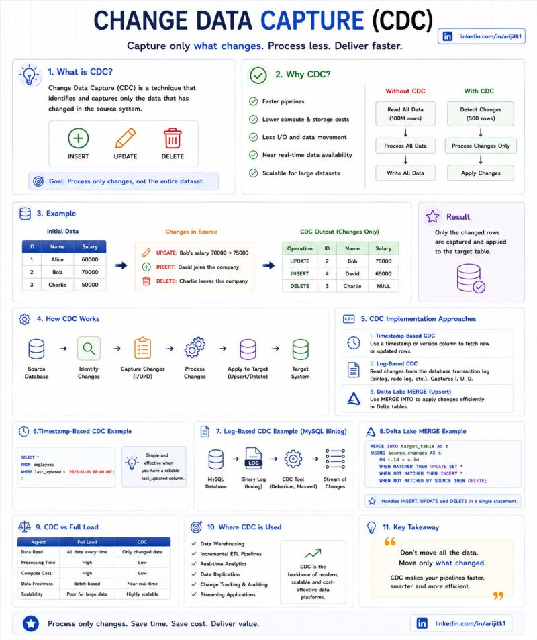

𝗘𝘃𝗲𝗿𝘆 𝗱𝗮𝘁𝗮 𝗽𝗶𝗽𝗲𝗹𝗶𝗻𝗲 𝗮𝗻𝘀𝘄𝗲𝗿𝘀 𝗼𝗻𝗲 𝗾𝘂𝗲𝘀𝘁𝗶𝗼𝗻: 𝘄𝗵𝗮𝘁 𝗰𝗵𝗮𝗻𝗴𝗲𝗱?
The brute-force answer is: reload everything and diff it. That works - until the source table has 500 million rows and your batch window is 4 hours.
Change Data Capture (CDC) tracks only what changed since the last read. But before choosing a method, the real question is: what does "change" mean in your system? A new row? An update? A delete? If you can't define change in business terms, your CDC stream becomes noise.
𝗛𝗲𝗿𝗲 𝗮𝗿𝗲 𝟰 𝗖𝗗𝗖 𝗺𝗲𝘁𝗵𝗼𝗱𝘀 - 𝗲𝗮𝗰𝗵 𝘄𝗶𝘁𝗵 𝗱𝗶𝗳𝗳𝗲𝗿𝗲𝗻𝘁 𝘁𝗿𝗮𝗱𝗲-𝗼𝗳𝗳𝘀:
→ 𝗧𝗶𝗺𝗲𝘀𝘁𝗮𝗺𝗽-𝗕𝗮𝘀𝗲𝗱
Query rows where updated_at > last_run. Simple. No source changes needed. Risk: misses deletes entirely and requires a reliable timestamp column. In practice, timestamp reliability is often assumed - not validated.
→ 𝗧𝗿𝗶𝗴𝗴𝗲𝗿-𝗕𝗮𝘀𝗲𝗱
Database triggers write changes to a shadow table. Captures inserts, updates, and deletes. Risk: adds overhead to the source database. DBAs often push back.
→ 𝗟𝗼𝗴-𝗕𝗮𝘀𝗲𝗱
Read the database transaction log directly. Zero impact on source performance. Captures everything including deletes. Risk: requires log access and tool support.
→ 𝗗𝗶𝗳𝗳-𝗕𝗮𝘀𝗲𝗱
Pull full snapshot, compare with previous. Works on any source. Risk: expensive at scale - only practical for small-to-medium tables.
𝗧𝗵𝗲 𝗱𝗲𝗰𝗶𝘀𝗶𝗼𝗻 𝗳𝗿𝗮𝗺𝗲𝘄𝗼𝗿𝗸:
Source has reliable timestamps → Timestamp-Based
Need deletes + source allows triggers → Trigger-Based
High volume + minimal source impact → Log-Based
No source access or small tables → Diff-Based
CDC isn't one technique. It's choosing the method that fits your source constraints, volume, and freshness requirements.
What CDC method does your team rely on most?
♻️ Repost to help others
➕ Follow Arunkumar for data engineering and integration insights
hashtag#DataEngineering hashtag#ChangeDataCapture hashtag#DataArchitecture
Activate to view larger image,


